[PSoC 4 Pioneer Kit Community Project#030 – Bluetooth with GLCD](http://www.element14.com/community/message/79651" \l "79651/l/psoc-4-pioneer-kit-community-project030-bluetooth-with-glcd)

We wanted to continue with our Android Bluetooth example from yesterday. Today we will be creating a Bluetooth example using an Android smartphone communicating to the Pioneer kit to make selections on a GLCD screen.

[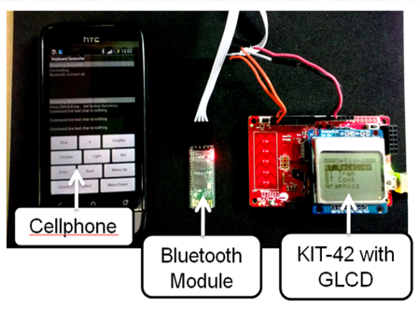](http://www.element14.com/community/servlet/JiveServlet/showImage/2-79651-155030/003+-+Example+Image.png)

 Yesterday we focused on Arduino compatible shield examples. Today we are using non-standard Bluetooth and GLCD screens. While we are pushing the Arduino shields for these designs we like to stress that the Pioneer kit can interface with non-Arduino hardware.

* CY8CKit-042
* [GLCD Module](https://www.sparkfun.com/products/10168)
* [BlueTooth Module](http://www.amazon.com/JY-MCU-Arduino-Bluetooth-Wireless-Serial/dp/B009DZQ4MG)

[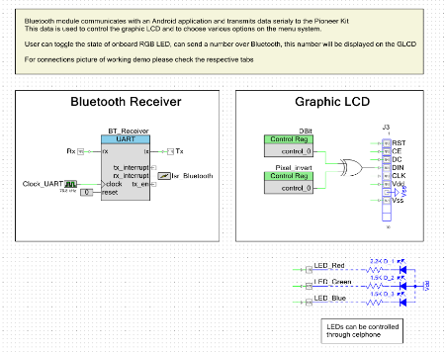](http://www.element14.com/community/servlet/JiveServlet/showImage/2-79651-155031/001+-+Schematic+View.png)

 Forum Post Attachments:

 At the bottom of this post we are including the following items:

* Example Project Zip File
* Zip File of Images
  + Project Schematic
  + Component Configurations

 Components Used:

 The user can download the example project at the bottom of this post. The project uses the following list of Creator Components:

* UART
* Control Registers
* ISR
* CyPins
* CyClock
* Kit-042 Annotation Library

 The components are configured by right clicking on the component in your Top Design schematic view and selecting **Configure**. Please enable the following selections in the Configuration windows for the listed components above.

 Firmware Description:

 The main.c firmware is included in the example project. Please review the commented sections for more details.

 If you need any additional information on the shields that we are using today please take a moment to review the following web pages:

* [GLCD Module](https://www.sparkfun.com/products/10168)
* [BlueTooth Module](http://www.amazon.com/JY-MCU-Arduino-Bluetooth-Wireless-Serial/dp/B009DZQ4MG)

 Please shop around for the best price on these modules. The example is meant to show you how to  interface with some non-standard modules.

 This example also uses the Bluetooth SPP app for Android phones. This app is available for Android phones only, and can be found at the following link:

* [Bluetooth SPP](https://play.google.com/store/apps/details?id=mobi.dzs.android.BluetoothSPP&hl=en)

 As part of this example we've used code from an ourside source to control the GLCD module. In this example we have APIs available to drive the GLCD module. These APIs are described in the Display.h file. We've linked to that code in the main.c file.

 In this example the Pioneer kit uses the Bluetooth module to connect to a Bluetooth network. Once the Pioneer kit is connected to the network the user can enter in characters to the SPP application to control the selections on the GLCD screen. The Bluetooth module communicates to the Pioneer kit using the UART component at 9600 baud. You will be able to navigate through the menu on the GLCD screen using your Android phone.

 The GLCD menu selections will allow you to select different RGB LED configurations on the Pioneer kit.

 Hardware Connections:

 For this example we will be wiring the modules to the Pioneer kit. The GLCD module should be inserted into the J3 header (pins 1-8). The Bluetooth module is connected to pins P1[0], P1[1], GND, and 5.0V.

[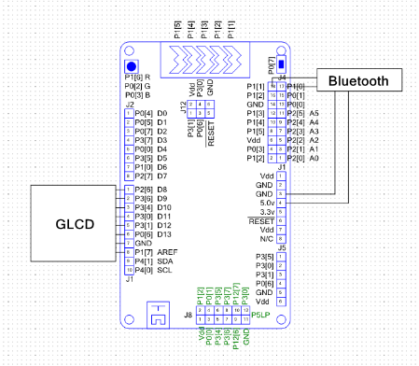](http://www.element14.com/community/servlet/JiveServlet/showImage/2-79651-155032/002+-+Wiring+Connections.png)

 Test Your Project:

 Program the Pioneer kit, start the SPP application and then begin to send command controls to the Pioneer kit to control the GLCD screen.

 I hope this example can help you in your design.

<http://www.element14.com/community/message/79651>